

Research Project Report

RepRap Distributed Processing
Status: Ongoing

1. Summary

A distributed RepRap controller system is being researched that would allow a low-cost master controller running Linux (a Raspberry Pi) to drive Arduino-Uno-based slave controllers using an I2C network, with one slave per device (stepper, heater) in a RepRap.

An initial slave has been designed and tested with a Raspberry Pi. It works to specification, but minor improvements need to be made to it before proceeding to the next stage of making multiple copies and writing the software to use the system to control an entire RepRap.

2. The problem

The microcontroller is a significant proportion of the BoM cost of a RepRap (around 28% for a low-cost machine). And having one microcontroller means that any expansion requires a similar extra cost for an additional slave controller PCB.

3. The proposed solution

At the very start of the RepRap Project the first purpose-designed controller was a distributed one, with satellite processors – one for each component like a motor or a heater. The data transfer was done with a TTL-level RS232 ring incorporating a PC that was the master controller. This system was very easy to expand: adding a component just meant adding a cheap satellite processor. But the ring bandwidth was always too low, and latency in the multi-tasking PC gave further timing difficulties.

It is proposed to research a much improved distributed RepRap controller with a higher bandwidth and a dedicated timing system for must-happen-now events so as to avoid latency issues in the master controller.

4. Solution specification

- I2C network between multiple simple Arduino Uno (ATMEGA328) processors
- Raspberry Pi master controller
- Extra clock and interrupt lines to do timing and synchronization
- Two versions of each PCB: a) small-as-possible SMD, b) one-sided millable through hole
- 12/19/24V power
- 3V3 logic (to match the Pi).
- C++ software

5. Experiments

A prototype controller was designed with an ATMEGA328 processor, a Pololu stepper controller and two MOSFET power switches for heaters, and two thermistor inputs for temperature measurement. The Pololu was used for convenience – it would probably not be the controller
chosen for a final version. The intention was that the board might be partly populated if it was just needed to control, say, a heater alone.
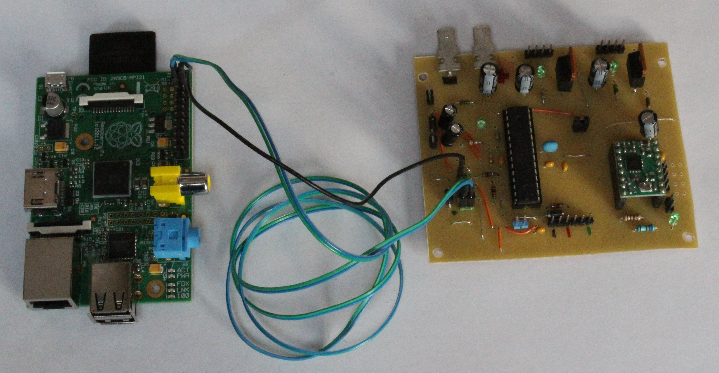
The One-sided millable through-hole PCB was created from the design and manufactured. The picture shows it connected by three-wire I2C to a Raspberry Pi.

6. Results

All the needed separate functions of the PCB and Pi were tested:

- Stepper driving
- Heater switching
- Temperature measurement
- I2C communications at 100K bps.

And work satisfactorily.

Some modifications were found to be needed to the PCB for the next stage of the research:

- Add an extra I2C connection so the boards can easily be chained without relying on chaining IDC connectors.
- Reduce the number of extra lines with the I2C to make wiring and routing easier.
- Small modifications to the MOSFET gate circuitry (a 1M resistor added between G and S).
- The addition of 4K7 pullups on the I2C lines. (Do these need to be bigger as there will be four or five of them in parallel on a final system?)

7. Future work

The circuit will be modified as described. A simple distributed controller program will be written for the Arduinos that allows a distributed DDA to run on them to control multiple steppers synchronously using the extra clock lines. Note that the DDA will have to have a short ring buffer of moves so that data for the next move can be loaded by I2C while the current move is running.

Heat control PID routines will be written to allow each Arduino to control temperatures.

A simple G-Code interpreter will be written for the Raspberry Pi to allow 3D prints to be run experimentally.

Much of this software will be based on parts of the existing Duet Firmware.

Adrian Bowyer
28 November 2015

